PROJECT: ADVANCED JAVA

# Employee Management System:

The purpose of the software requirements document is to systematically capture requirements for the project and the “Employee Management System” to be developed. Both functional and non-functional requirements are captured in this document. It also serves as the input for project scoping.

The scope of this document is limited to addressing the requirements from a user, quality, and non-functional perspective.

**Purpose**

In the current system, Admin adds new regulations and assigns them to the department manually. Department Head sends these regulations to the individual users through mail to get their consent. Users send their comments through the courier service after reading regulations. Department head has to collect the user inputs and pass them on to Admin. Since a lot of manual workflow is involved, it is time consuming for Admin to close each regulation.

So, a new system is required to automate this regulation creation and closure process.

**In Scope**

Employee information creation and maintenance

Department creation and maintenance

Regulation creation and maintenance

Mapping each employee to the respective department

Updating/viewing user comments on the assigned regulations

**Out Scope**

Loading the employee list into the application

Notifications on the status

**Current system flow**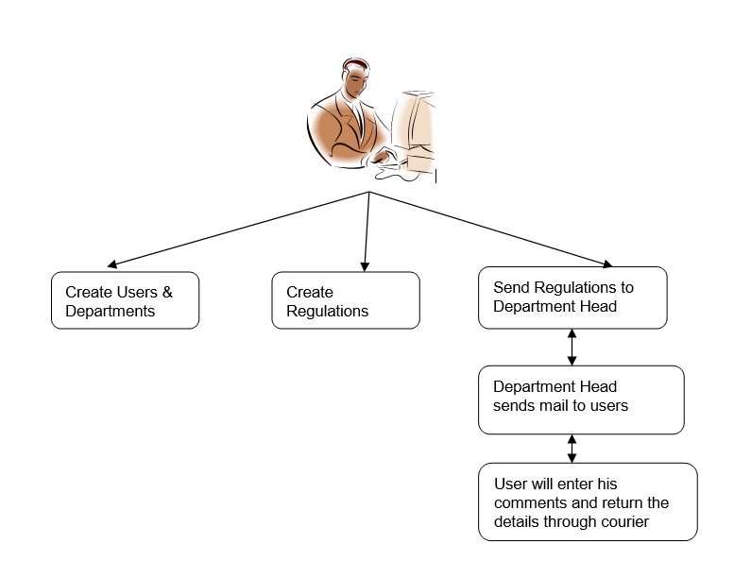

**Business Requirements**

|  |  |  |
| --- | --- | --- |
| **#** | **Rule Name** | **Definition** |
| 1 | Mandatory Employee Fields | The system should check if the following details are being entered while adding/editing a new Employee:   * First Name * Last Name * DOB * Department   Appropriate message should be thrown as an alert. |
| 2 | Business Validation | While Adding an Employee, the system should not allow the entry of Employee who is not older than 24 years into the system.  Appropriate message should be thrown as an alert. |
| 3 | Mandatory Department Fields | The system should check if the following details are being entered while adding a new Department:   * Department Name   Appropriate message should be thrown as an alert. |
| 4 | Compliance of RL document | The RL document should be marked as closed only after all the employees of a department have submitted a status report. |
| 5 | Mandatory Regulation Fields | The system should check if the following details are being entered while adding a new Regulation   * Regulation details * Regulation creation date   Appropriate message should be thrown as an alert. |
| 6 | Mandatory User Comments Field | The system should check if the following details are being entered while adding a new Regulation   * Regulation Comments. * Comments creation date   Appropriate message should be thrown as an alert. |

**High Level Business Requirements**

|  |  |  |  |  |
| --- | --- | --- | --- | --- |
| **S.No** | **Business Requirement ID** | **Short Description** | **Description in detail** | **Interacting Business Processes** |
| 1 | BR001 | Login with different roles User, Admin | There should be provision to login as Admin or as User. | NA |
| 2 | BR002 | Add Employee | Admin should be allowed to add employee details using HTML. | NA |
| 3 | BR003 | View Employees | There should be provision for Admin/User to see the entire Employee list in the organization using HTML. | NA |
| 4 | BR004 | Edit Employee | Admin should be allowed to edit employee details using HTML. | NA |
| 5 | BR005 | Delete Employee | Admin should be allowed to delete employee details using HTML. | NA |
| 6 | BR006 | Add Department | Admin should be allowed to add department using HTML. | NA |
| 7 | BR007 | View Department | Admin should be allowed to view department list using HTML. | NA |
| 8 | BR008 | Create RL - Admin | Admin should be allowed to add new regulation/legislation and map it to department using HTML. | NA |
| 9 | BR009 | View RL - Admin | Admin should be allowed to view already added regulation/legislation using HTML. | NA |
| 10 | BR010 | View RL - User | The system should allow the employees to view the regulations assigned to them using HTML. | NA |
| 11 | BR011 | Update User Comments - User | Should allow the users to update the comments for the regulation assigned to them using HTML. | NA |
| 12 | BR012 | View User Comments - User | Should allow the users to view the comments updated by them using HTML. | NA |

**Detailed Business Requirements**

|  |  |  |  |  |  |  |
| --- | --- | --- | --- | --- | --- | --- |
| **S.No** | **Req. #** | **Business Requirement** | **Req. Type \*** | **Priority \*\*** | **Originator \*\*\*** | **BR Traced to Business Requirement/ Use case ID** |
| 1 | BR001 | Provision to login with two different roles, namely, Admin and User.  View, Add, Edit Employee; Create RL; and Add Department operations must be permitted when logged in as Admin.  When logged in as User, View RL and Update and View Comments operations must be permitted. | F | 1 | Employee Management Web App | NA |
| 2 | BR002 | From Web App, Admin should be allowed to enter the following details for the Employee:   * First Name * Last Name * DOB * Email * Department | F | 1 | Employee Management Web App | NA |
| 3 | BR003 | In Web App, the Admin can see the list of all employees in the organization. The web app must capture the following information:   * User Id * First Name * Last Name * DOB * Email * Department | F | 1 | Employee Management Web App | NA |
| 4 | BR004 | In Web App, Admin should be allowed to Edit any employee.  Web App should allow the admin to edit the following details:   * First Name * Last Name * DOB * Email * Department | F | 1 | Employee Management Web App | NA |
| 5 | BR005 | From Web App, Admin should be allowed to delete the required Employee. | F | 1 | Employee Management Web App | NA |
| 6 | BR006 | From Web App, Admin should be allowed to enter the following details for the Department   * Department * Name | F | 1 | Employee Management Web App | NA |
| 7 | BR007 | From Web App, Admin can view the department list. The web app must capture the following information:   * Department Id * Department Name | F | 1 | Employee Management Web App | NA |
| 8 | BR008 | From Web App, Admin should be allowed to create a new Regulation/Legislation document. It should capture the following fields.   * RL Type * RL Details * Creation Date * Department | F | 1 | Compliance Tracking | NA |
| 9 | BR009 | From Web App, Admin Should be allowed to View the RL for each department. It should display the following fields.   * RL Id * RL Type * Description * Creation Date * Department * Status | F | 1 | Compliance Tracking | NA |
| 10 | BR010 | From Web App, View RL -User should allow the employees to view the regulations assigned to them. The Employees should be allowed to view the previously created status report. | F | 1 | Compliance Tracking | NA |
| 11 | BR011 | From Web App, admin should allow the user to update the comments for each regulation assigned to them.   * User Comments * Date | F | 1 | Compliance Tracking | NA |
| 12 | BR012 | From Web App, Users should be allowed to view the Comments entered by them. | F | 1 | Compliance Tracking | NA |

**\* Req. Type**

F Core Functionality,

E Exception,

UI User Interface

R Reporting

**Business Objective Traceability Matrix**

|  |  |  |  |  |  |
| --- | --- | --- | --- | --- | --- |
| **Business Objective** | **Business Requirement Number** | **Priority** | **Requirement Title** | **How requirement satisfies objective** | **Status** |
| To maintain the employee details in an application | 1 | High | Employee Management Web App | Allows the Admin to maintain the employee details effectively | Open |
| To track the compliance of each law to closure | 2 | High | Compliance Tracking | Allows the Admin to create and track the new law effectively | Open |

**Functional Specification**

The Employee Management Web application can be integrated by linking all the modules. EMP is basically a system that helps maintain employee information, map employees to departments, create RL documents, and track compliance and user comments.

Important modules in the system:

1. Employee Record Maintenance – Add, Edit, Delete, View Employees.
2. Departments – Add, View Department
3. Regulations/Legislation – Create, View Regulation
4. Compliance Tracking

This document details the requirements for overall integrated application. This application can be accessed by administrators and registered users only.

**Integrated application features**

1. Application should have single login page. Login page should be the welcome page for the application.

2. Only registered users and administrators should be able access the application.

3. Users should not be able to access any application feature without login.

4. There should be a logout feature. Once logged out, users should come to the welcome page or design logout page to re-login.

5. Application home page must have facility to access the following functionalities:

1. Admin users must be able to Add, Edit, Delete, and View Employees
2. Admin users must be able to Add and View Department
3. Admin users must be able to create regulation and View regulation status of all departments.
4. Users must be able to View Regulations assigned to them.
5. Users must be able to View and Update their Comments on regulation.
6. Users must be able to track Compliance of department through status.

6. At any point of time, user should be able to go back to homepage.

7. None of the features should be accessible if session expires.

8. Logged in users should be tracked through session.

7. If user clicks the back button after logout, browser pages should not be accessible.

8. On login, user credentials should be validated against those of the registered users in the system.

9. Log in page should have username and Password fields to receive username and password and should have login button.

10. Password must be encrypted.

11. Username and password cannot be blank.

12. If the username and password do not exist in the system, application should show proper error message.

**Integrated application non-functional features**

1. Exceptions should not be shown on web app.

2. No debug message should appear on web app.

3. All the errors and exceptions should be logged to log file.

4. Log file path should be configurable.

5. Database connections should be configurable and should not be hard coded.

**Table Structure and Relationship**

